Nicholas Skinner

CS475

Spring 2019

**Project #3 - Functional Decomposition**

**Choice Quantity**

For my submission, I decided to use wolves as a variable to reduce the deer population. This was implemented easily enough, wolves will eat a specified number of deer, if too many wolves are in the area, or too few deer exist, the population of wolves will reduce accordingly. If an ‘extinction’ of wolves occurs, new wolves are able to enter the area, provided that enough deer exist to sustain a new population.

**Table**

|  |  |  |  |  |  |
| --- | --- | --- | --- | --- | --- |
| **Month** | **Precip** | **Temp** | **Height** | **Deer** | **Wolves** |
| **1** | 5.701 | -4.657 | 0 | 3 | 2 |
| **2** | 8.39 | -1.781 | 0.72 | 1 | 3 |
| **3** | 9.881 | 4.603 | 8.213 | 0 | 2 |
| **4** | 12.489 | 16.796 | 8.266 | 1 | 1 |
| **5** | 9.681 | 21.755 | 7.767 | 2 | 1 |
| **6** | 7.006 | 18.387 | 6.78 | 2 | 2 |
| **7** | 5.457 | 21.442 | 5.781 | 3 | 2 |
| **8** | 2.496 | 13.163 | 4.669 | 3 | 3 |
| **9** | 0.739 | 15.321 | 3.242 | 4 | 3 |
| **10** | 0 | 5.509 | 4.079 | 2 | 4 |
| **11** | 2.758 | -0.141 | 5.475 | 3 | 3 |
| **12** | 4.711 | 3.136 | 9.697 | 4 | 3 |
| **13** | 8.173 | -2.22 | 9.531 | 4 | 4 |
| **14** | 12.225 | 5.49 | 14.88 | 5 | 4 |
| **15** | 13.48 | 8.811 | 16.201 | 5 | 5 |
| **16** | 13.188 | 9.992 | 16.367 | 6 | 5 |
| **17** | 10.528 | 19.335 | 13.373 | 6 | 6 |
| **18** | 7.83 | 16.159 | 10.462 | 7 | 6 |
| **19** | 3.374 | 23.833 | 6.962 | 7 | 7 |
| **20** | 2.324 | 19.156 | 3.466 | 6 | 7 |
| **21** | 0.191 | 11.288 | 1.137 | 5 | 6 |
| **22** | 0 | 9.87 | 0 | 4 | 5 |
| **23** | 0 | 0.403 | 0 | 3 | 4 |
| **24** | 4.216 | 1.384 | 2.726 | 2 | 3 |
| **25** | 8.853 | 3.989 | 9.569 | 3 | 2 |
| **26** | 9.949 | 1.454 | 14.056 | 3 | 3 |
| **27** | 11.061 | 2.616 | 19.655 | 4 | 3 |
| **28** | 13.593 | 13.827 | 18.061 | 4 | 4 |
| **29** | 10.404 | 21.634 | 16.061 | 5 | 4 |
| **30** | 8.794 | 15.339 | 13.73 | 5 | 5 |
| **31** | 3.001 | 19.941 | 11.232 | 6 | 5 |
| **32** | 3.259 | 22.321 | 8.232 | 6 | 6 |
| **33** | 0.334 | 10.468 | 6.202 | 7 | 6 |
| **34** | 1.427 | 8.088 | 5.197 | 5 | 7 |
| **35** | 3.048 | 7.165 | 6.579 | 6 | 6 |
| **36** | 5.478 | 2.319 | 9.212 | 7 | 6 |
| **37** | 9.187 | 1.211 | 11.376 | 7 | 7 |
| **38** | 10.422 | 3.075 | 15.391 | 8 | 7 |
| **39** | 11.095 | 2.026 | 17.931 | 8 | 8 |
| **40** | 12.894 | 17.766 | 13.955 | 9 | 8 |
| **41** | 9.452 | 14.97 | 9.675 | 9 | 9 |
| **42** | 7.363 | 24.217 | 5.175 | 10 | 9 |
| **43** | 4.6 | 19.7 | 0.178 | 8 | 10 |
| **44** | 1.971 | 21.151 | 0 | 7 | 9 |
| **45** | 0 | 13.606 | 0 | 6 | 8 |
| **46** | 0 | 7.452 | 0 | 5 | 7 |
| **47** | 2.171 | 3.892 | 1.792 | 4 | 6 |
| **48** | 6.393 | -1.103 | 2.383 | 3 | 5 |
| **49** | 6.4 | -4.397 | 1.442 | 2 | 4 |
| **50** | 11.561 | 2.026 | 6.901 | 1 | 3 |
| **51** | 10.676 | 11.109 | 8.289 | 2 | 2 |
| **52** | 9.964 | 16.87 | 7.343 | 3 | 2 |
| **53** | 10.067 | 12.962 | 6.605 | 3 | 3 |
| **54** | 9.304 | 15.4 | 5.268 | 4 | 3 |
| **55** | 6.299 | 16.271 | 3.343 | 4 | 4 |
| **56** | 2.064 | 20.472 | 1.344 | 3 | 4 |
| **57** | 1.424 | 10.585 | 0.974 | 2 | 3 |
| **58** | 0 | 2.457 | 2.564 | 1 | 2 |
| **59** | 2.127 | -2.866 | 2.826 | 2 | 1 |
| **60** | 3.039 | 2.217 | 6.022 | 2 | 2 |
| **61** | 6.463 | -0.207 | 8.523 | 3 | 2 |
| **62** | 10.085 | 0.129 | 11.398 | 3 | 3 |
| **63** | 11.255 | 7.447 | 15.779 | 4 | 3 |
| **64** | 13.106 | 13.938 | 14.171 | 4 | 4 |
| **65** | 8.631 | 19.78 | 12.174 | 5 | 4 |
| **66** | 6.439 | 16.776 | 9.726 | 5 | 5 |
| **67** | 3.844 | 15.901 | 7.303 | 6 | 5 |
| **68** | 0 | 22.394 | 4.304 | 6 | 6 |
| **69** | 0.224 | 10.246 | 2.337 | 5 | 6 |
| **70** | 0.771 | 10.238 | 0.988 | 4 | 5 |
| **71** | 2.706 | 1.661 | 2.644 | 3 | 4 |
| **72** | 3.419 | -0.87 | 3.222 | 2 | 3 |

**Graph**

Below are two graphs displaying two common effects my variable had on the environment. It seemed to either level out variance in the default model, or wreak havoc and cause effective extinction in the area.

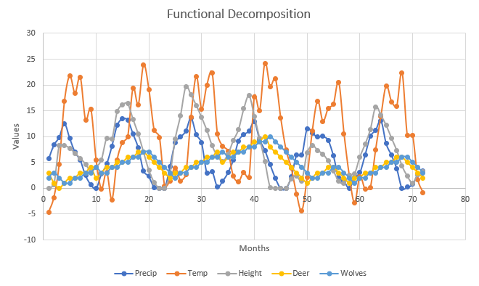

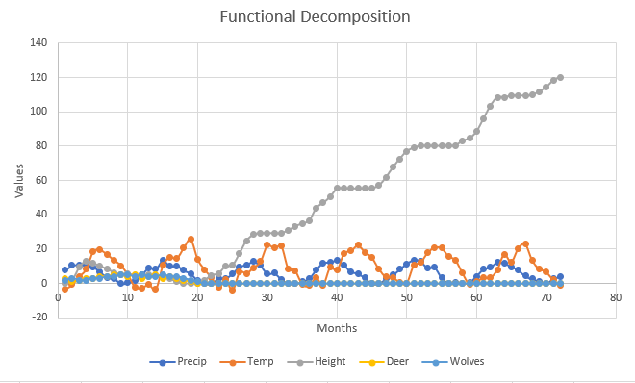

**Commentary**

The variable I threw into the model seems to either quell how quickly the population of deer increases, or decimate the population of deer in the area. The wolves depend on the deer to exist, and if they don’t, then the wolves cease to exist. It appears that some delicate balance in the grass growth determines whether or not the population is able to survive in the area. The proof for my variable’s influence on the model is in the extinction graph, both wolves and deer managed to die out, and not re-populate within the model, causing the grass to overgrow. If I were to re-visit my code for this program, I would likely reformat my wolf feeding and growth rates, making them equations based more heavily on the current population of deer, and making it harder for a 1-1 ratio of wolves and deer occuring.

1. Precipitation - Appears to follow a cosine wave with some added randomness
2. Temp - Appears to follow a sine wave with some added randomness
3. Height - the height of the grain is influenced by the temperature, the precipitation, as well as the number of deer. If deer did not exist in the equation, the grain would grow in waves through the year. If not enough grain exists for the deer to feed on, they will die off.
4. Deer - deer are influenced by the height of the grain, as well as the number of wolves. The amount of grain influences whether deer prosper or die off. The number of deer is also affected negatively by a growing wolf population
5. Wolves - Wolves are affected by the number of deer in the area, if too few deer exist, wolves will die off, too many deer, and wolves will prosper.